|  |  |  |
| --- | --- | --- |
| https://basin.cbu.edu.tr/db_images/site_500/web/cbu_logo_dik.png | **T.C.**  **MANİSA CELAL BAYAR ÜNİVERSİTESİ**  **MÜHENDİSLİK FAKÜLTESİ**  **BİLGİSAYAR MÜHENDİSLİĞİ BÖLÜMÜ** |  |

**.NET Web Programming Project**

**Tasarım Projesi**

**HAZIRLAYANLAR**

**210315003 Zeynep Naz CEYHAN**

**DANIŞMAN**

**Volkan ALTINTAŞ**

**MANİSA 2023**

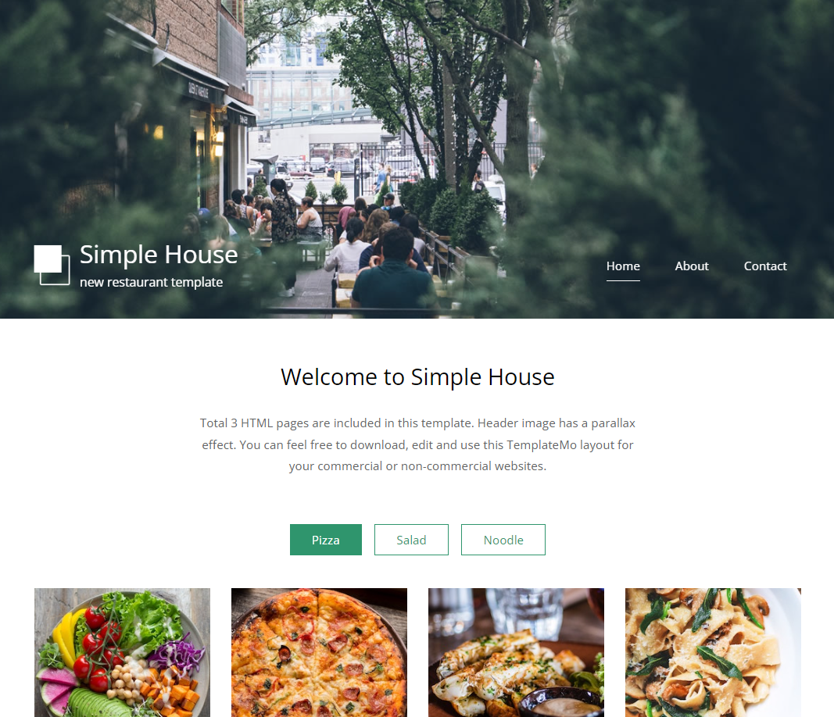

**I chose this template to use in this homework. My goal was changing the prices, pictures of foods, descriptions of foods part by using MVC and SQL.**

**After choosing template that I’m going to use then I installed Entity Framework to use in this project. And then I implemented the template in our project to use.**

**metin, ekran görüntüsü, yazılım, multimedya yazılımı içeren bir resim

Açıklama otomatik olarak oluşturuldu**

**In this part, I created a controller which is called FoodController. FoodController class is derived from Controller class.**

**Also we need to implement ‘using WebApplication3.Controllers’ to access this controller.**

**Then we need a db object which is created from context class. By using this object we created our datas into a list then we stored them in a FoodList. And returned them with using View.**

**In the end, we created a view for our Index.**

**metin, ekran görüntüsü, yazılım, multimedya yazılımı içeren bir resim

Açıklama otomatik olarak oluşturuldu**



metin, ekran görüntüsü, yazılım, yazı tipi içeren bir resim

Açıklama otomatik olarak oluşturuldu

**Here, we implemented “@using WebApplication3.Controllers;” to access models.**

**Also we need a list to do that we need to implement “@model List<Food>. In html part we changed the beginning html codes with a new html codes that are copied from our template.**

**Then i created a foreach loop. I can add new meals to the website.**

**metin, elektronik donanım, ekran görüntüsü, yazılım içeren bir resim

Açıklama otomatik olarak oluşturuldu**

**In Food class, there are some attributes of the Food class that are ProductId, Name, Price, Exp. Then we are going to use them in a database.**

**metin, ekran görüntüsü, yazılım, ekran, görüntüleme içeren bir resim

Açıklama otomatik olarak oluşturuldu**

**Here, we have a class named Context and it is derived from DbContext class. It is a bridge between entity classes and the database. DbSet represents an entity set than can be used for create, read, update and delete operations.**



**To make some changes in database we need to enable migrations with using “enable-migrations” command.**

**And we change the value of the AutomaticMigrationsEnabled to true to make changes in database automatically.**

**Then we update our database with using “update-database” command**.

**metin, ekran görüntüsü, sayı, numara, ekran, görüntüleme içeren bir resim

Açıklama otomatik olarak oluşturuldu**

**This is a image of our database. Then we are going to use these datas in the “index.cshtml”.**

**metin, ekran görüntüsü, yemek, gıda içeren bir resim

Açıklama otomatik olarak oluşturuldu**

**This is the last version of my template after the changes.**